AWS CloudWatch Monitoring Project

Monitor an EC2 instance and get **alerts when something goes wrong** (CPU high, server down, low disk, etc.).

EC2 = your server

CloudWatch = health monitor

Alarm = danger detector

SNS = message sender

Email = you get warning

Step 1: Launch an EC2 instance

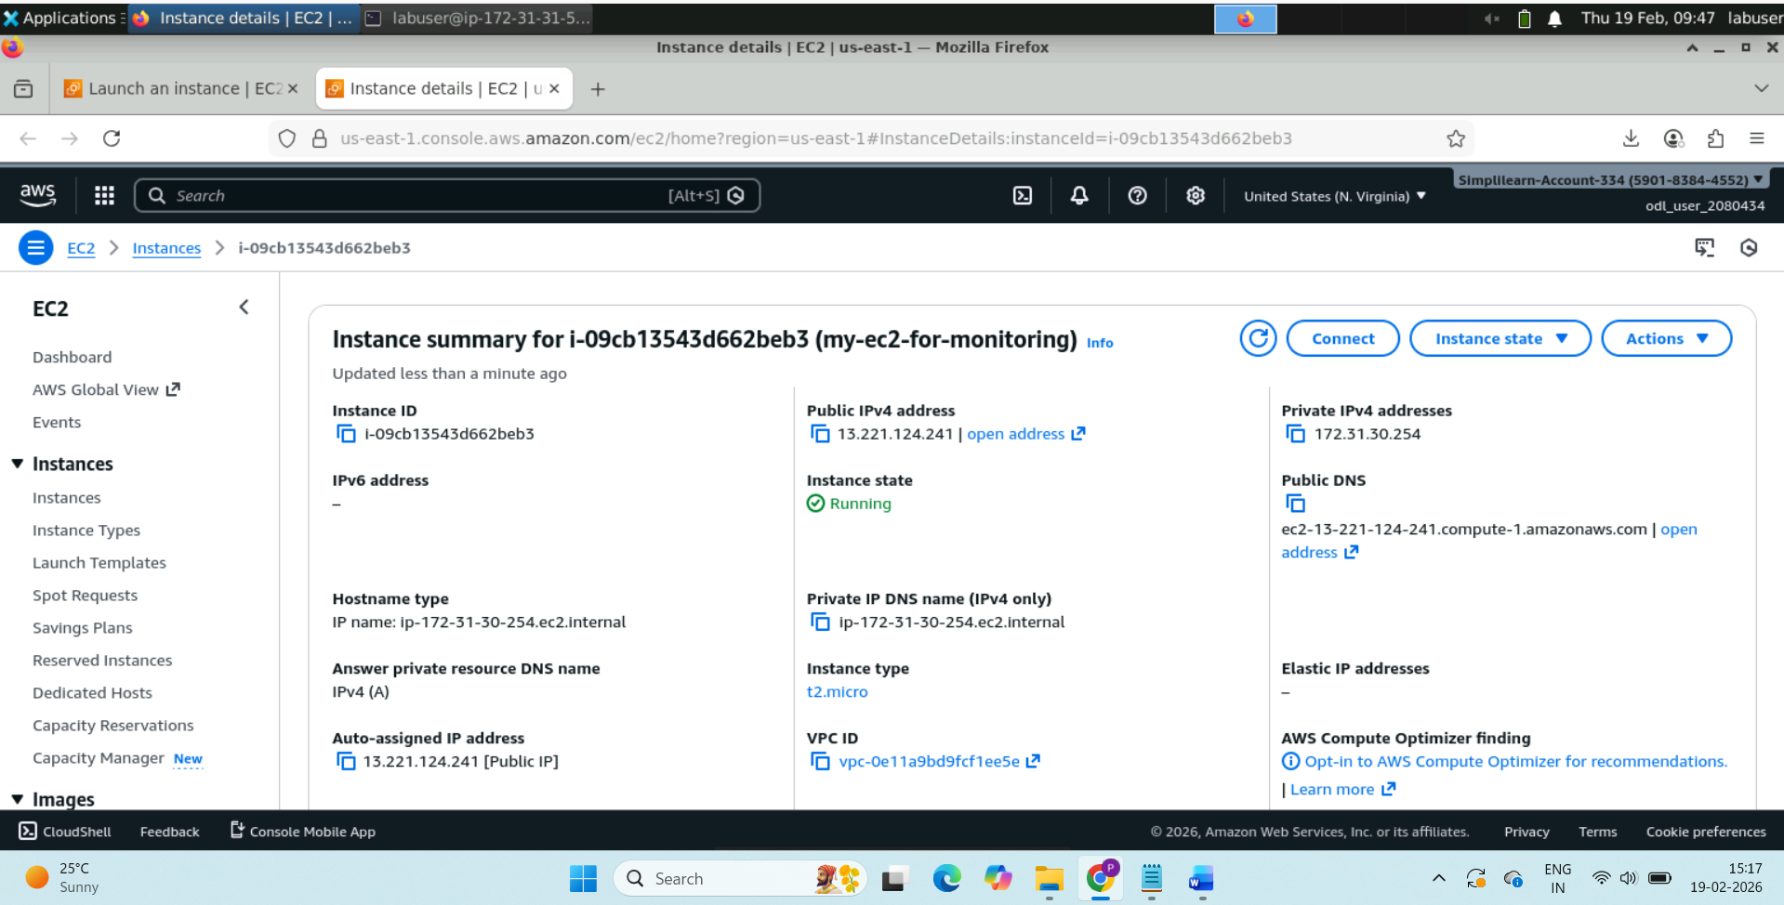

Step 2: Open terminal and paste the below command so that SSH allows entry to connect to EC2.

chmod 400 key-pair-for-monitoring.pem (It changes permissions to “read-owner only”)

If you’ll not provide below command and execute:

ssh -i key-pair-for-monitoring.pem [ec2-user@13.221.124.241](mailto:ec2-user@13.221.124.241), you’ll get below output:

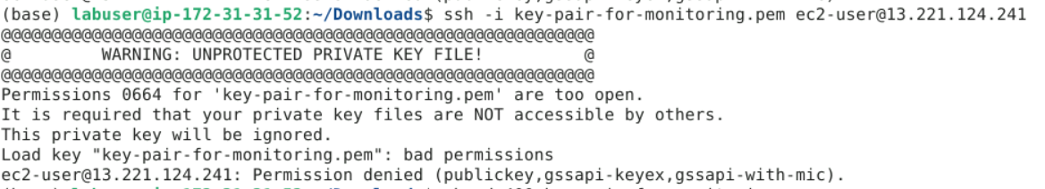

---------------------------------------------------------------------------------------------------------------------------------------------------

Connect to EC2:

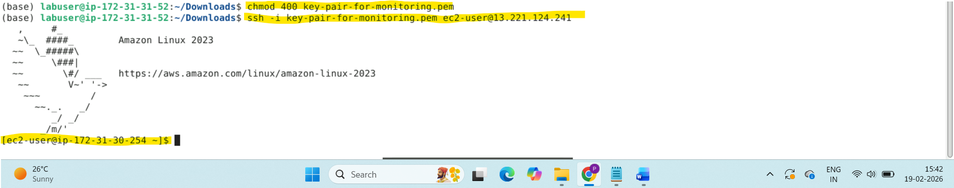

Now you’re connected to EC2 server.

Step 3: Install CloudWatch Agent

sudo yum install amazon-cloudwatch-agent -y

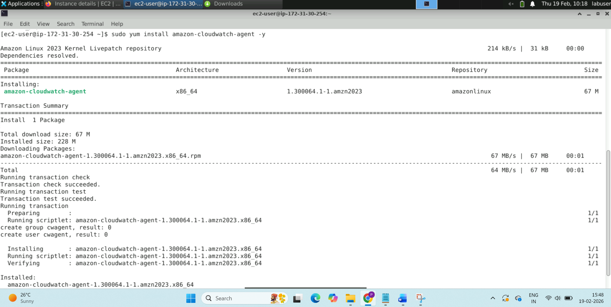



Step 4: Create IAM role for EC2

EC2 cannot send data to CloudWatch without permission.

So, create role for EC2 use case. Then Attach policy → CloudWatchAgentServerPolicy

Attach this role to your instance.

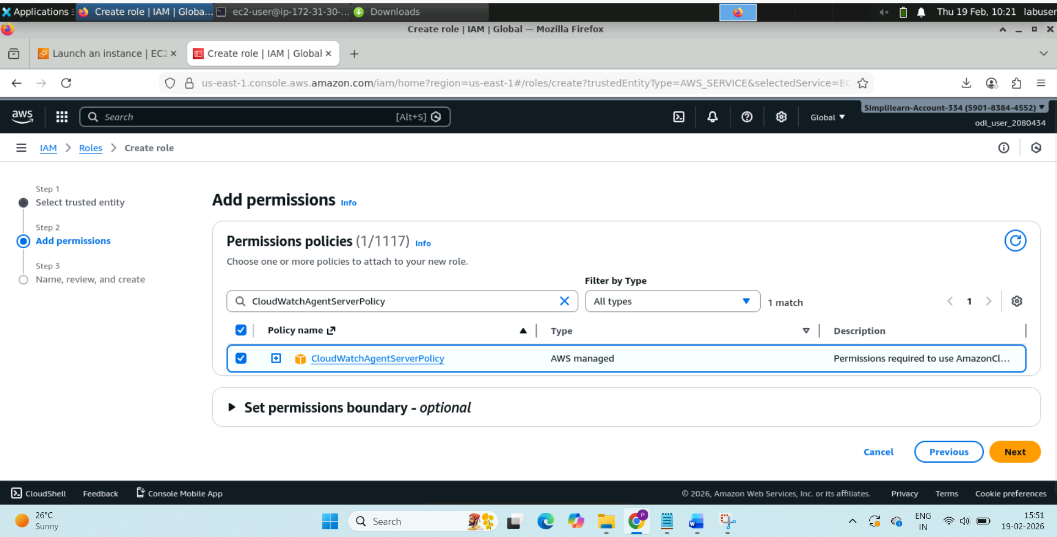

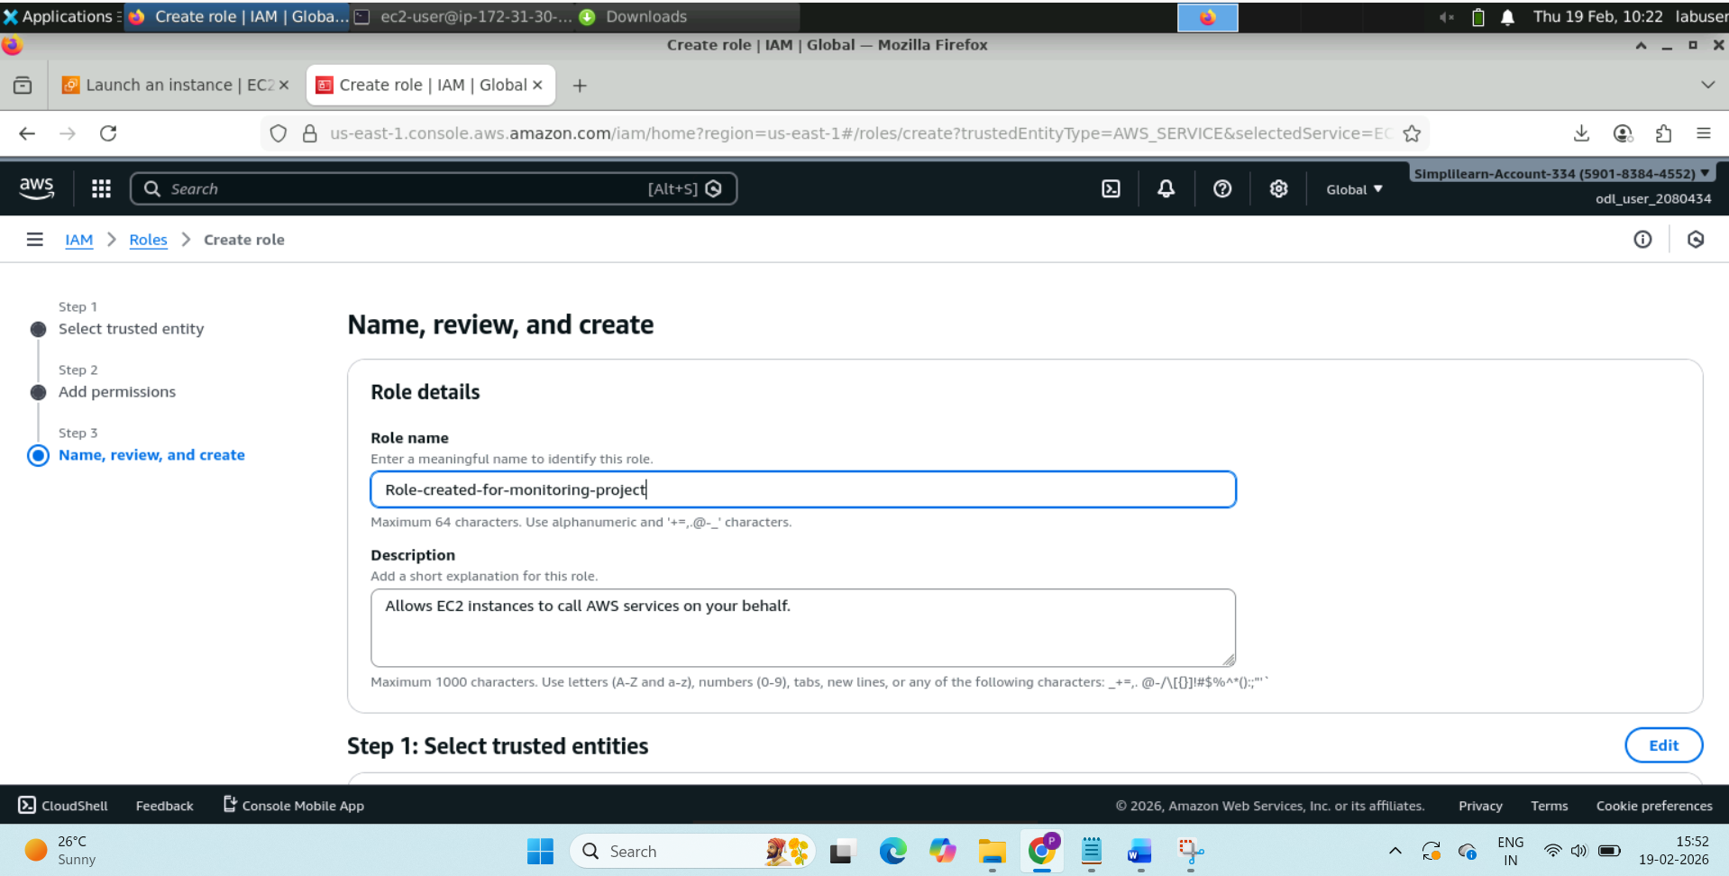

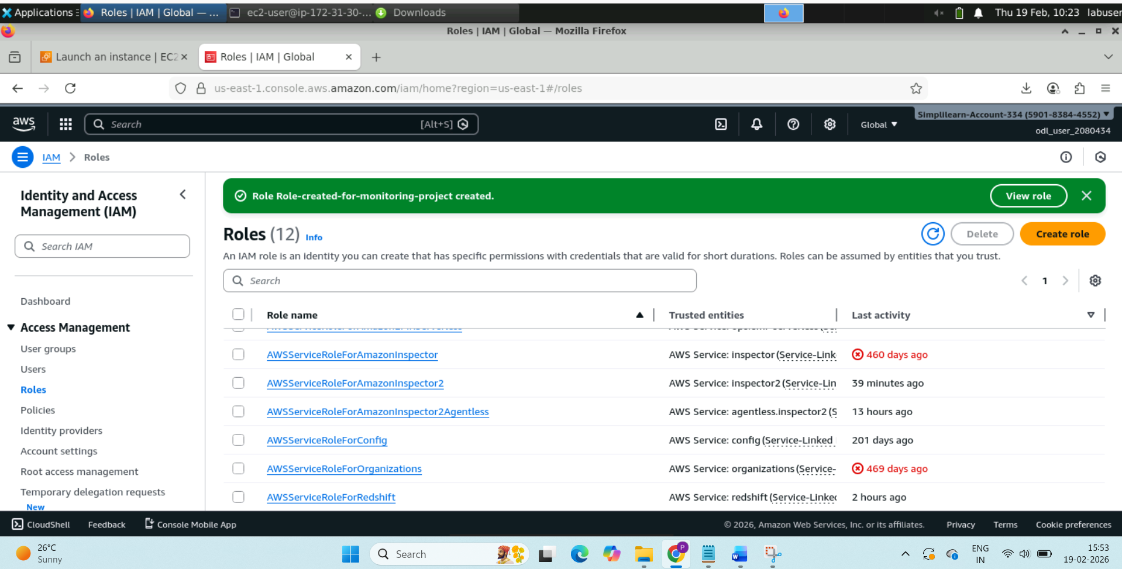

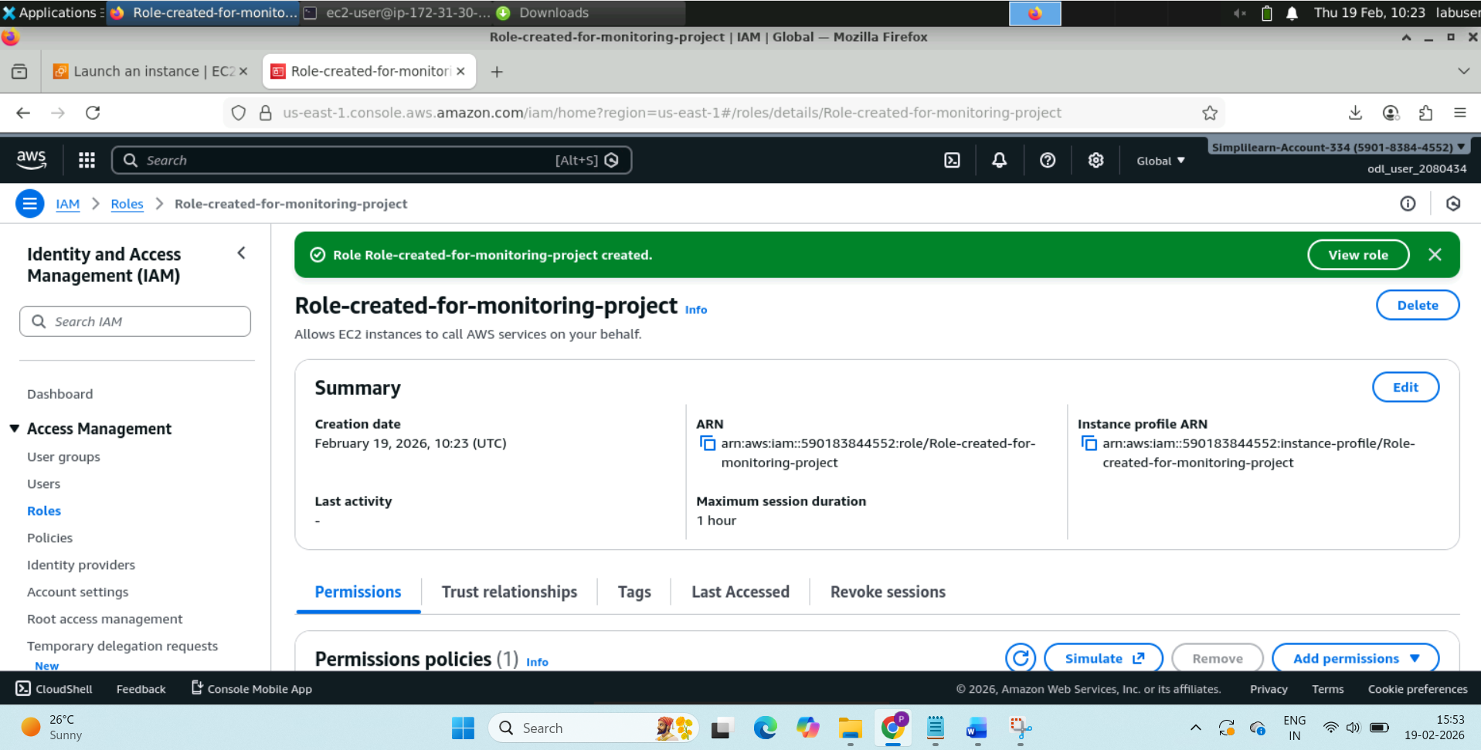

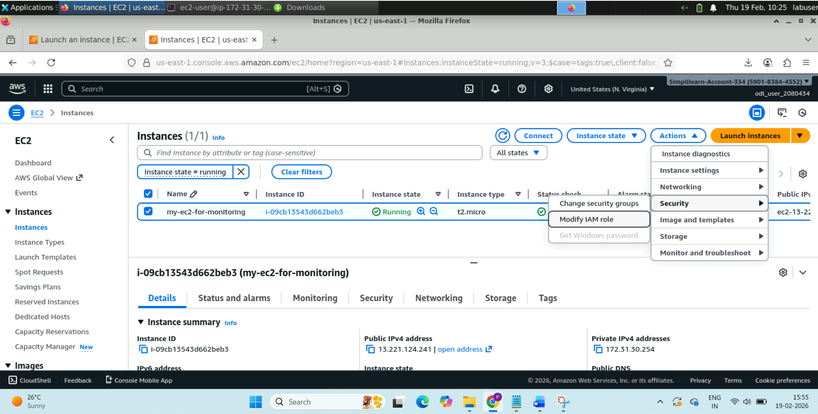

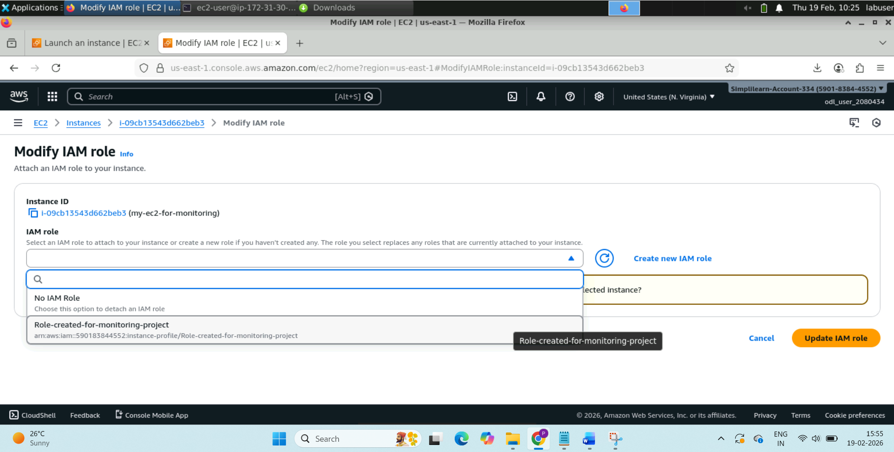

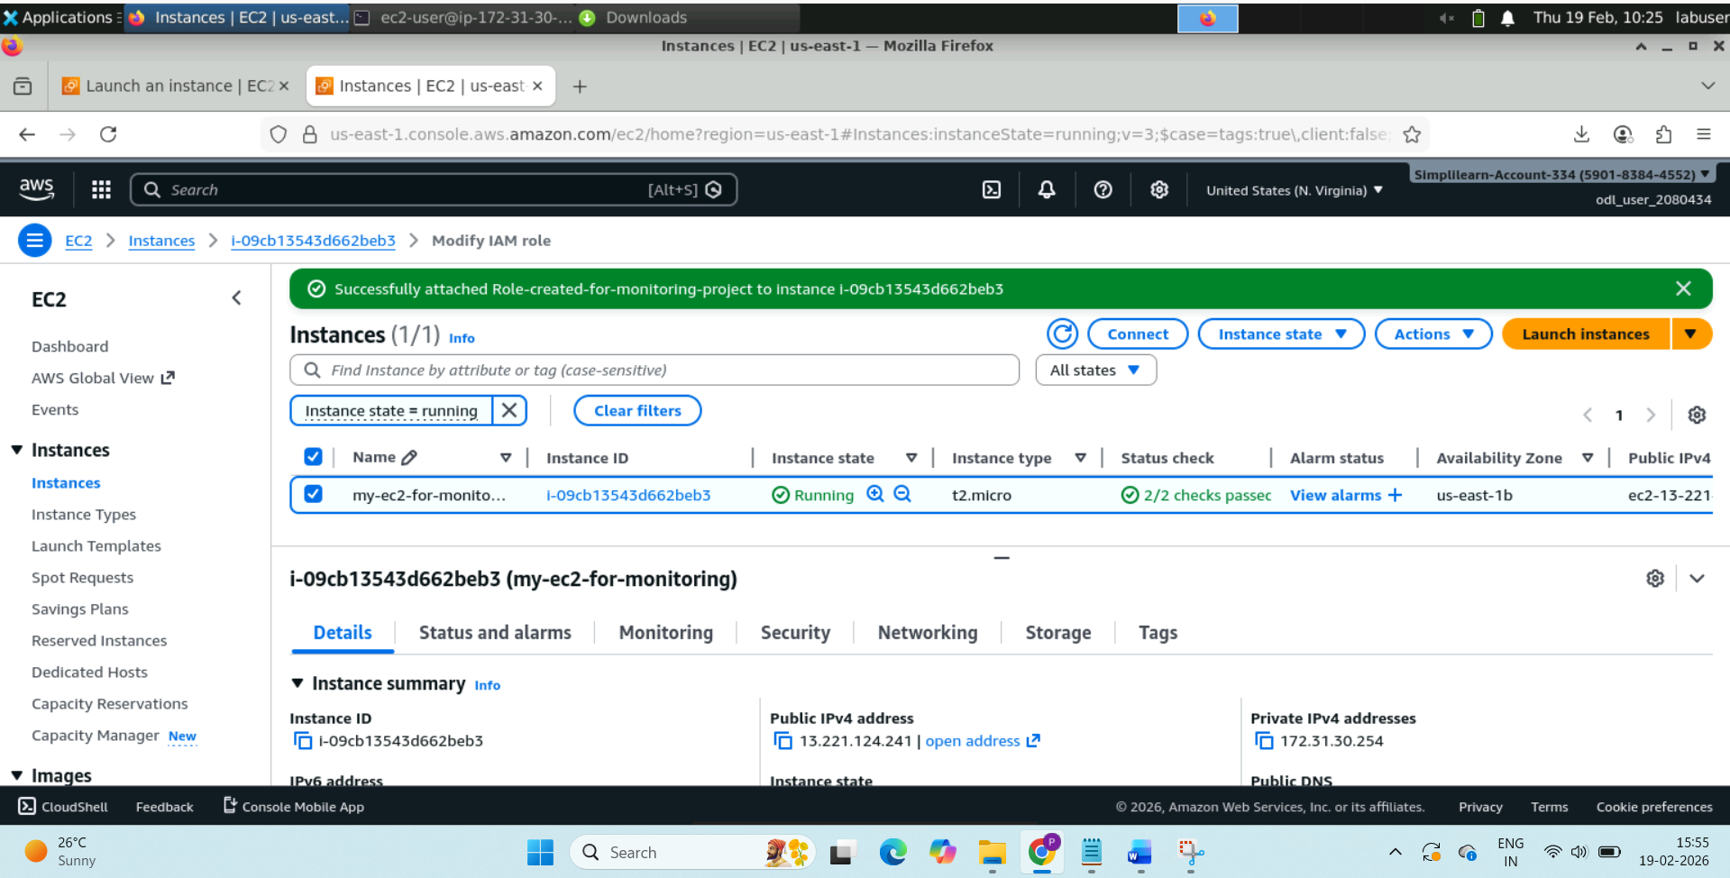

Step 5: Configure CloudWatch Agent

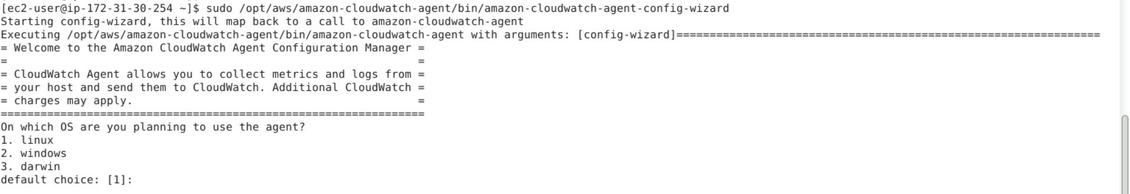

This screen means the **CloudWatch Agent setup wizard has started successfully**

You’ll get couple of questions to answer, do that.

Then start agent:

sudo systemctl start amazon-cloudwatch-agent

Step 6: Create SNS notification

Go to **SNS → Topics → Create topic**

Then:

* Create subscription
* Protocol → Email
* Enter your email
* Confirm from inbox

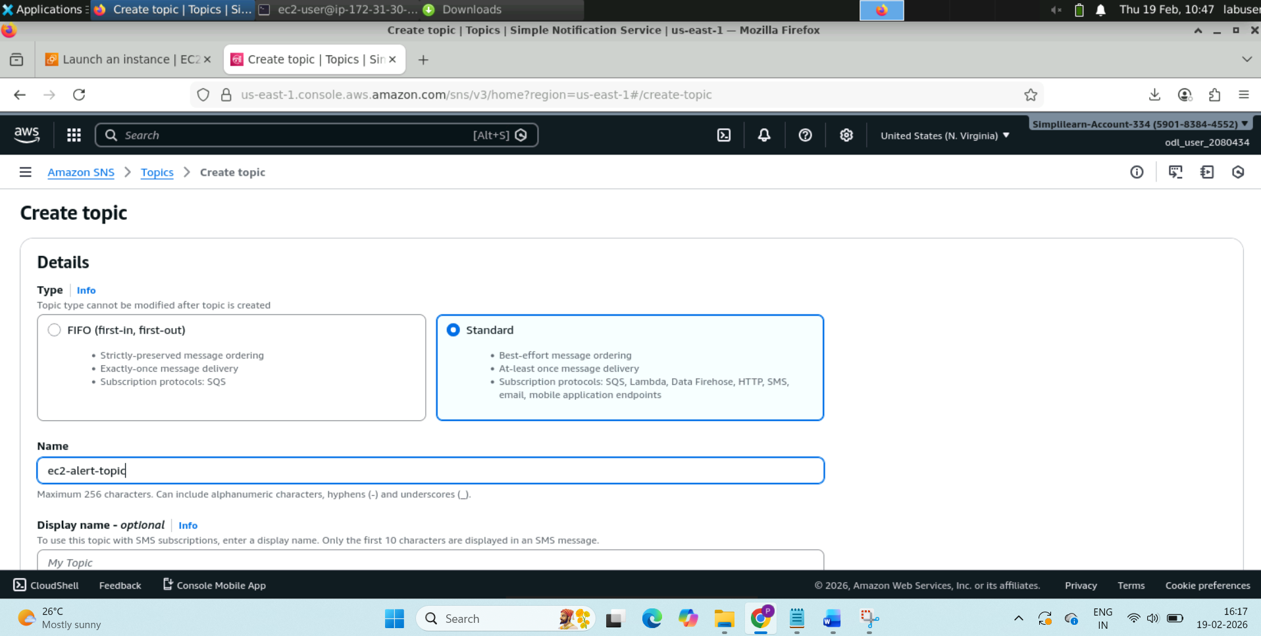

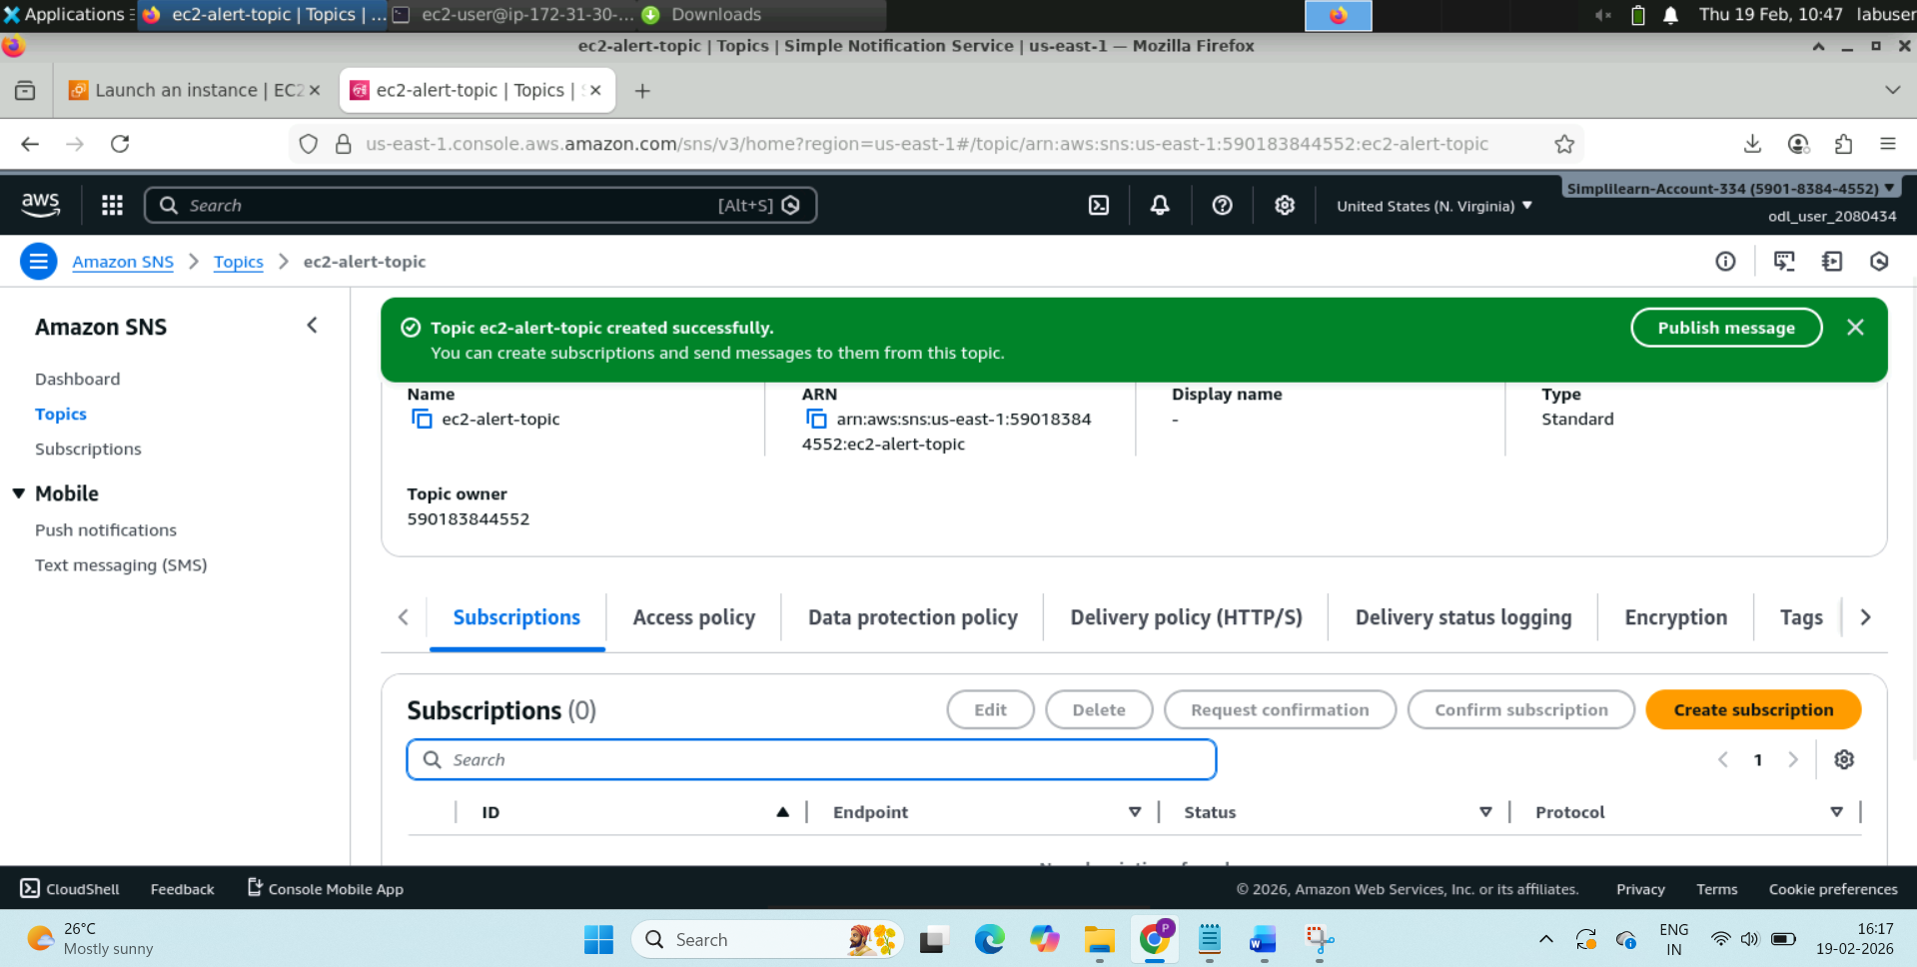

Subscription:

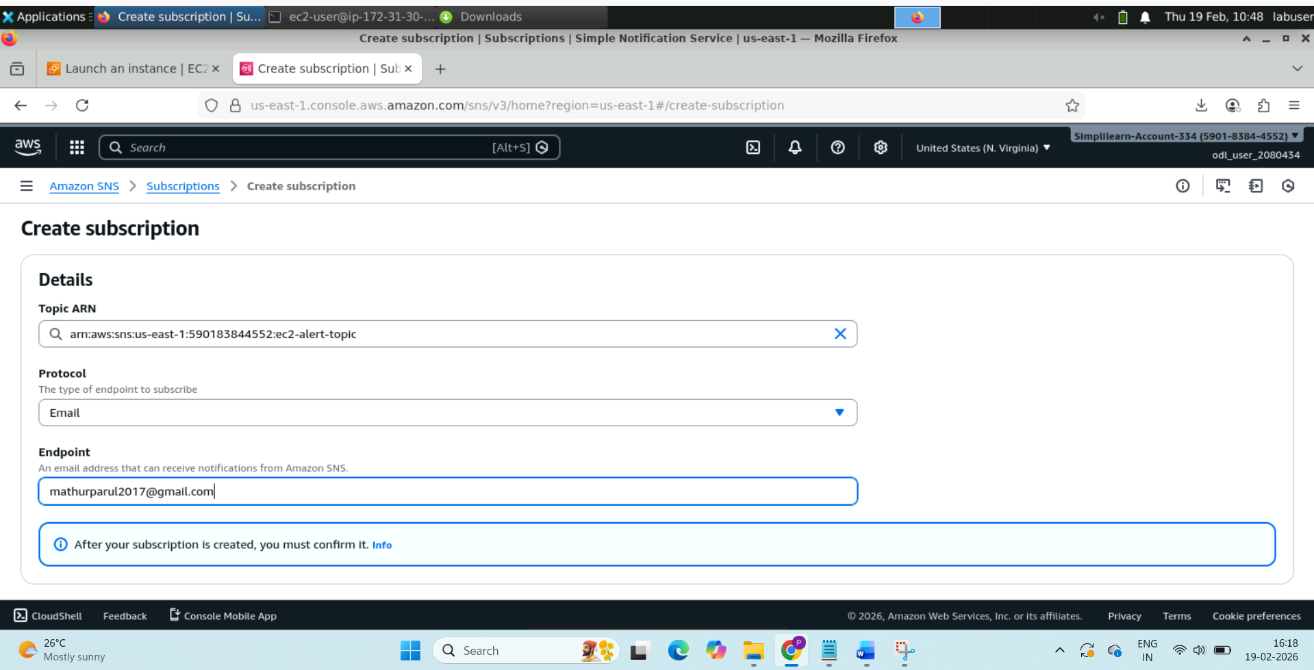

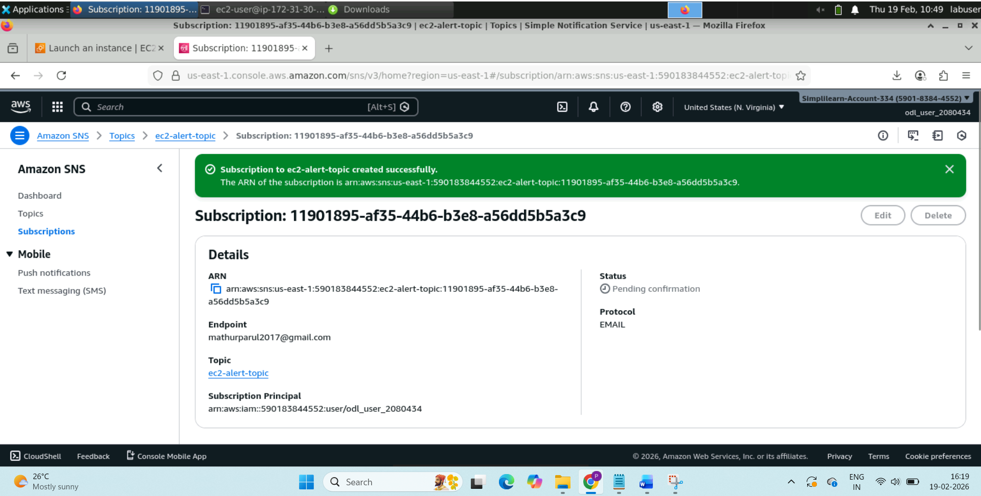

Open your email, and click on **Confirm subscription**

**Until you confirm, alarm will NOT send emails.**

**Step 7: Create alarm**

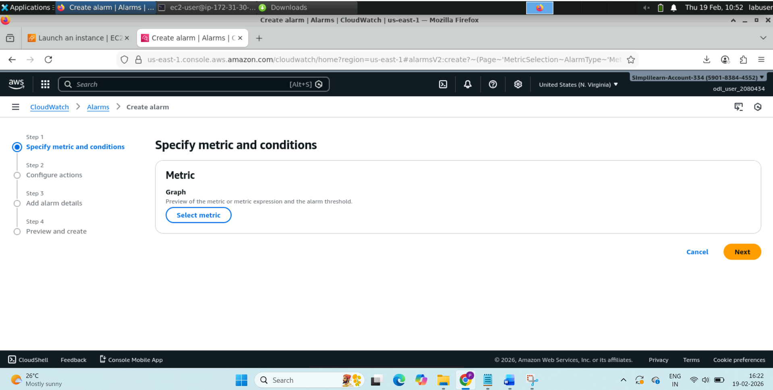

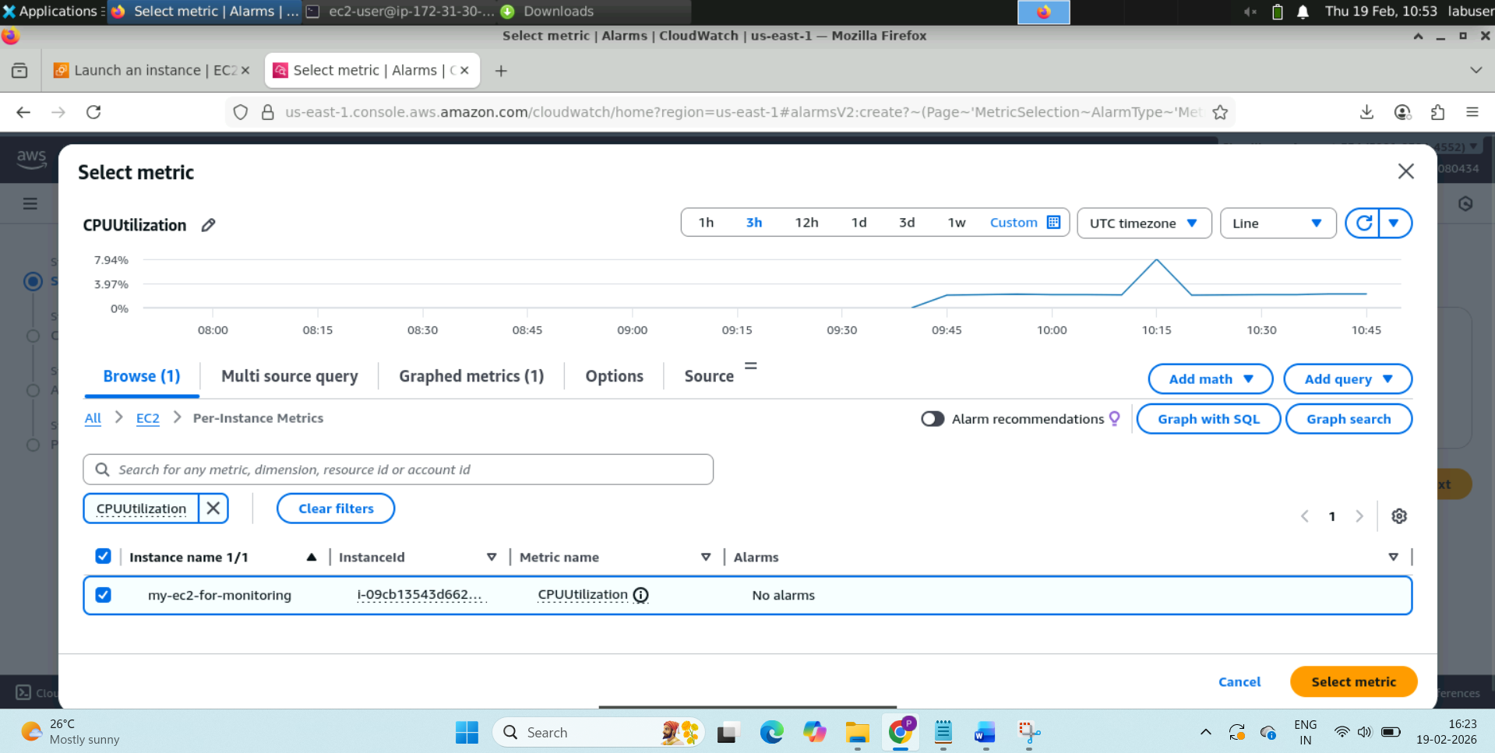

**Click on Select metric.**

**Then set the below condition:**

**CPU > 70% for 5 minutes**

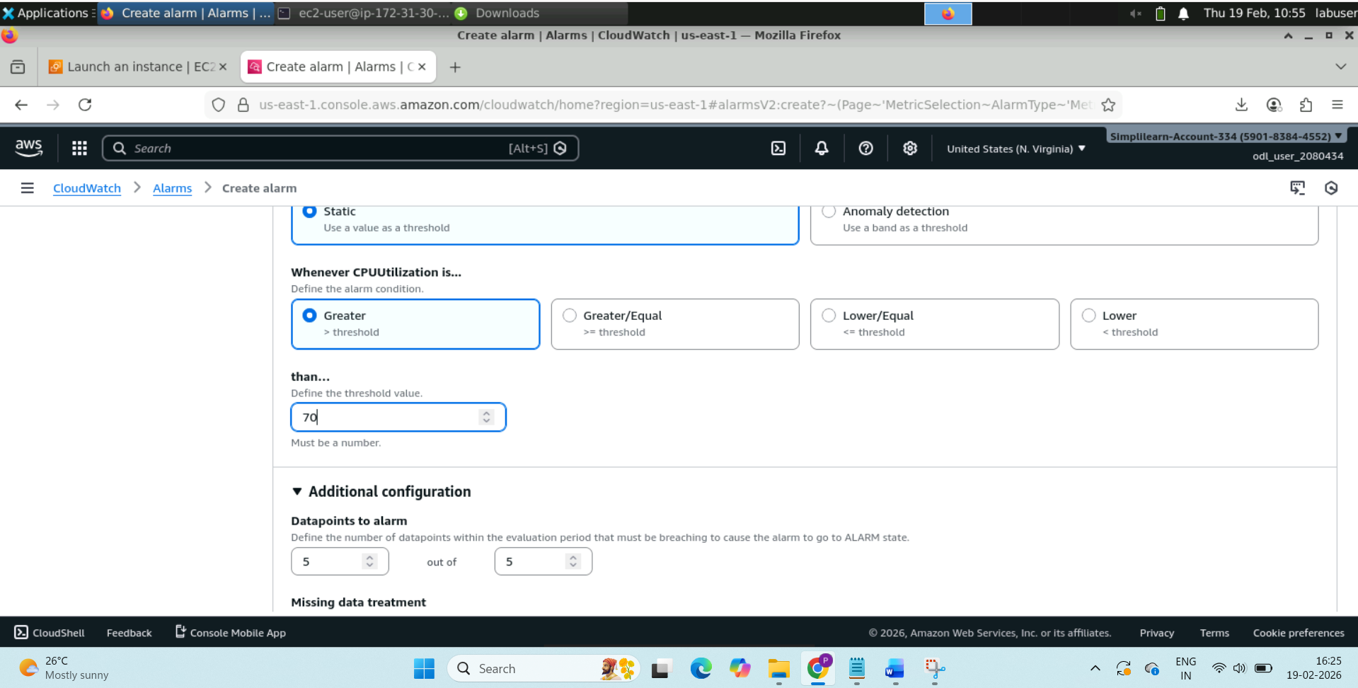

**Then click on next**

**Configure Actions:**

**→ Send notification to SNS topic**

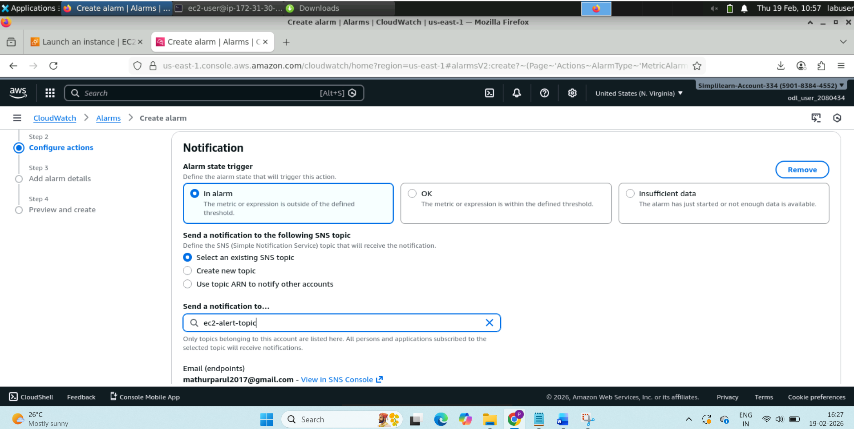

**Click on next**

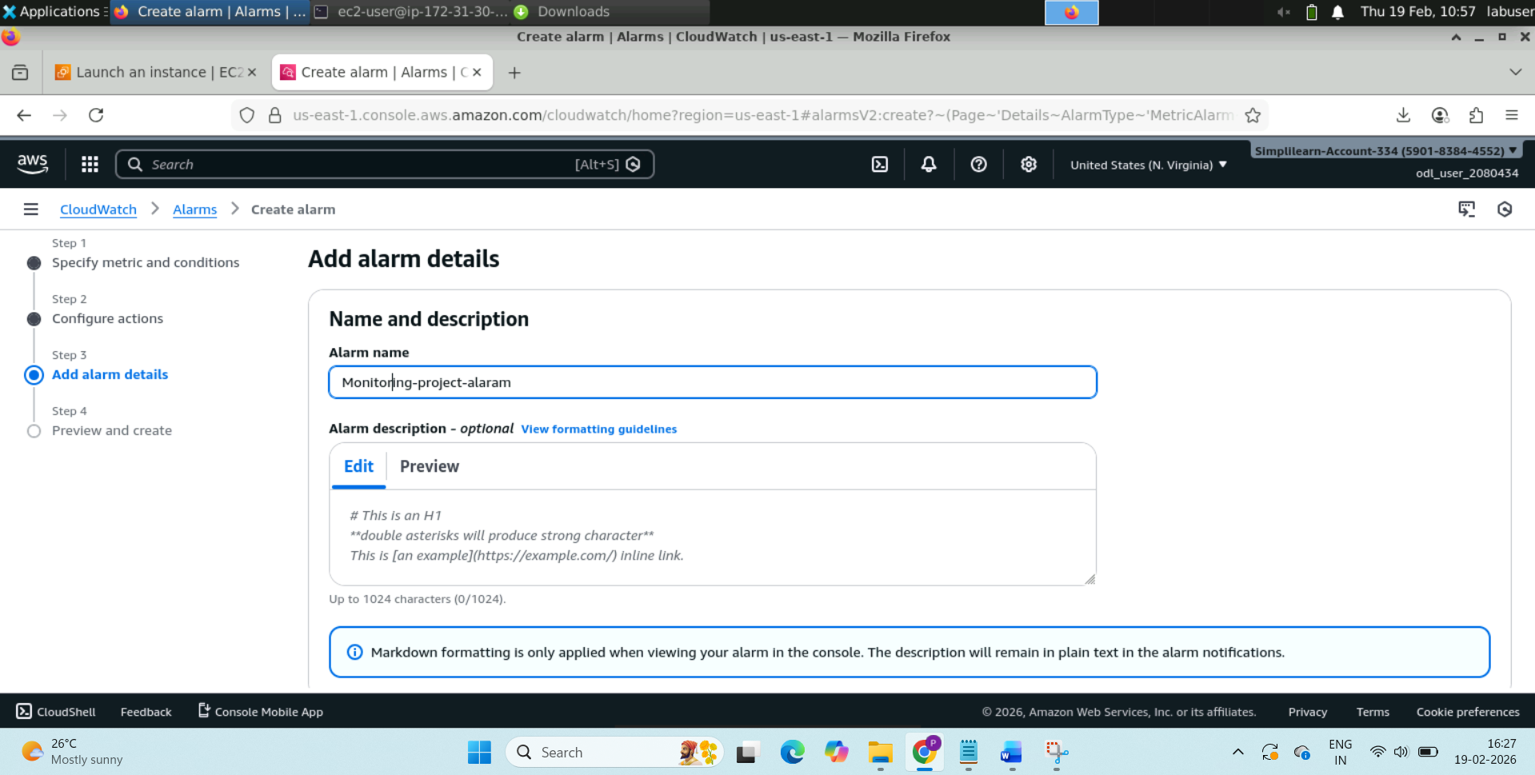

**Click on next and create alaram:**

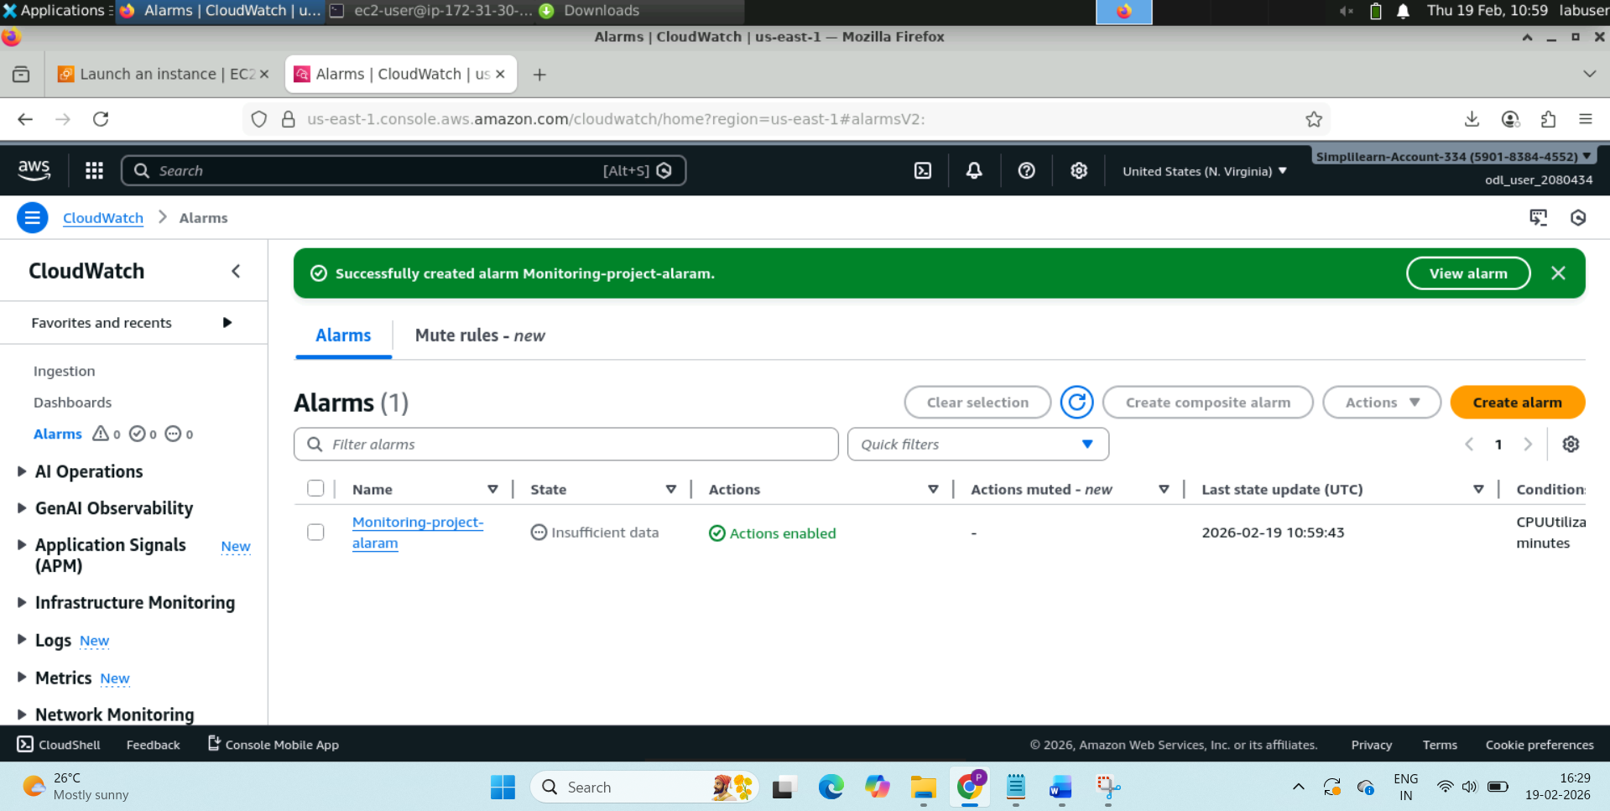

sudo yum install stress -y (install stress)

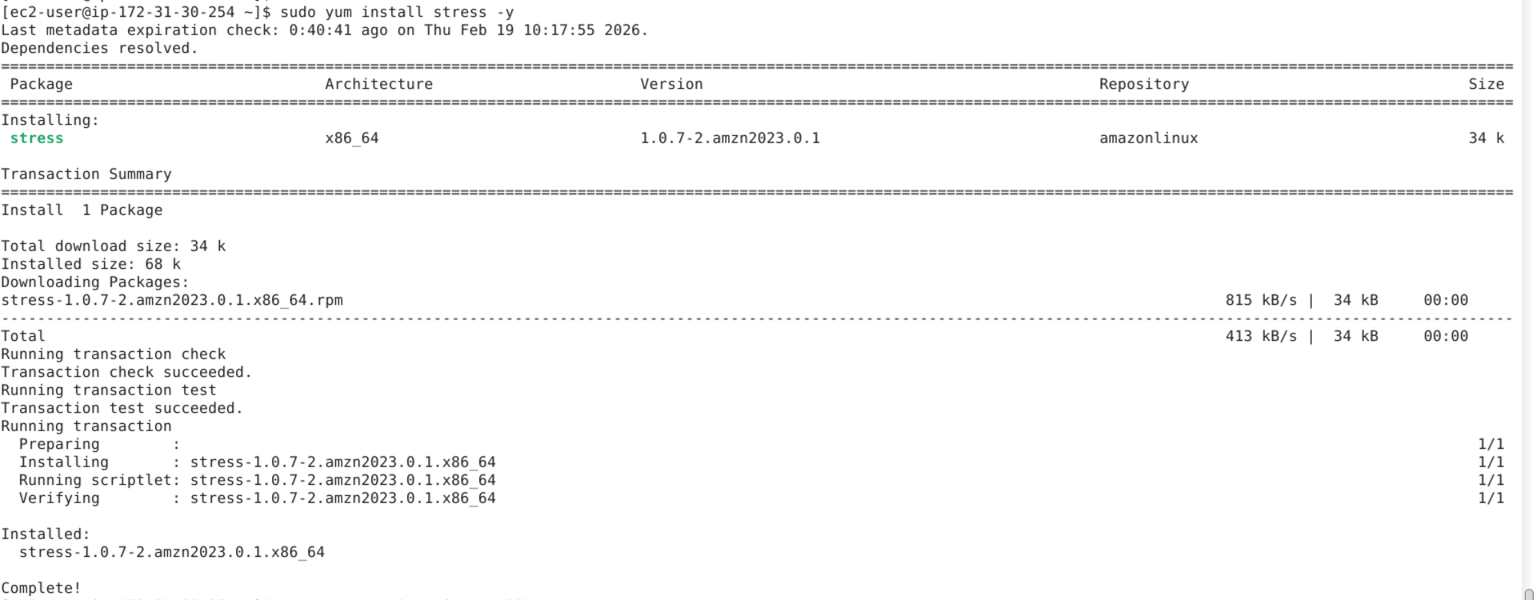

Installed.

**Now test the alarm, which is very important**

**stress --cpu 1 --timeout 300**